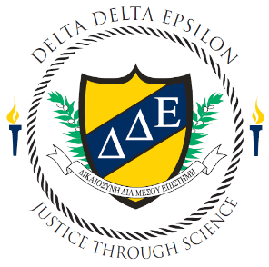
Delta Delta Epsilon

Student Travel Grant Application

AAFS Annual Conference

Orlando, Florida 2023

Application Deadline November 1, 2022
February 13th – 18th

Student Information
Name
Phone
E-Mail
University Affiliation
Graduate or Undergraduate Student
Year in School (freshman, sophomore, junior, senior, 1st year graduate student, 2nd year graduate student, etc.)
Have you been accepted to present research at AAFS? Indicate whether this is an oral or poster presentation.
Name and contact information for DDE Faculty Advisor including email address and phone number.

DDE Involvement
Please list all DDE activities, events, and community service opportunities in which you have participated. This should include any leadership positions you have held on your Chapter’s executive board.

Research Information
Briefly describe any research you are conducting/have conducted at your University.

Forensic Science Coursework
List all Forensic Science courses you have completed or are currently enrolled in.

Agreement and Signature
By submitting this application, I affirm that the facts set forth in it are true and complete. I understand that if I am selected for the DDE travel grant, I am required to fully comply with any and all rules and guidelines set before me.
Name (printed)
Signature
Date

Additional Requirements

Please attach a copy of your curriculum vitae.

If you are presenting slides or a poster at AAFS attach a copy of your abstract.
- Return to DDE Chair Caitlin Porterfield at cporterfield@uco.edu

